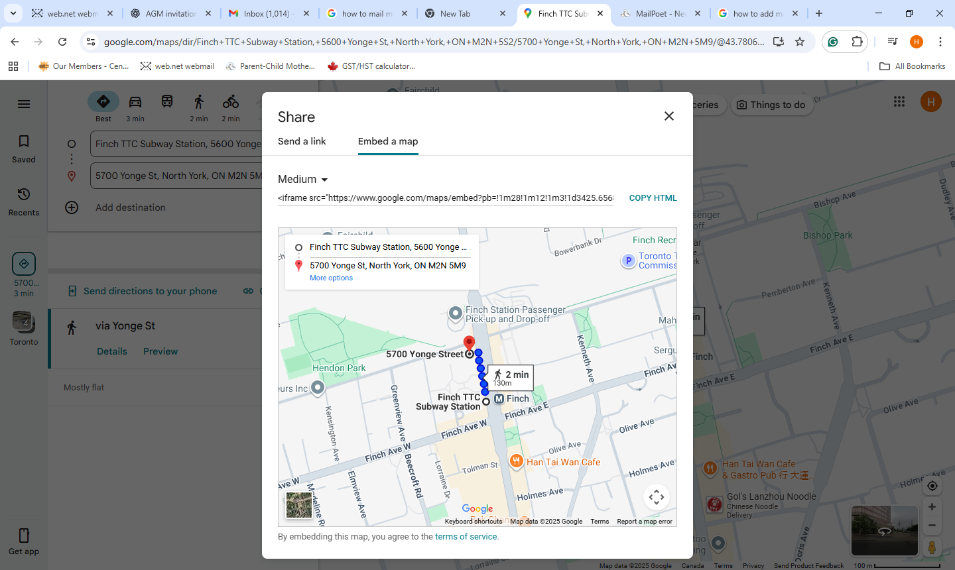

https://maps.app.goo.gl/6FBZHt6Zh4YV1iAF8

